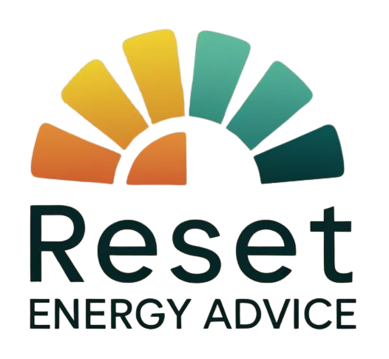
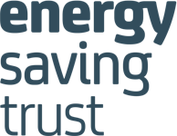


EMBARGOED TO 00:01 28 JULY 2025
NEW PROJECT RESETS THE DIAL ON ENERGY COSTS

A major £450k, two-year initiative to help people throughout Plymouth, Torbay, Exeter and South and East Devon reduce their energy bills and improve their finances has been launched today.
RESET, run by Citizens Advice South Hams, aims to help people out of fuel poverty and towards a more sustainable financial future.

According to the latest government statistics, more than 45,000 households in the RESET area are living in fuel poverty (1), including 11.6% of all -households in Exeter, 11.4% in the South Hams and also in Torbay, 11.3% in Plymouth, 10.3% in East Devon and 10.1% in Teignbridge.

Citizens Advice South Hams Chief Executive, Janie Moor, said:
“Although the cost-of-living crisis is no longer in the headlines, our advisers in Devon engage with people everyday struggling to cope financially, with many making the difficult choices between heating and eating.
“In our more marginalised rural and urban communities access to good, independent energy advice which could make all the difference to their weekly budget is difficult to find.
“Vulnerable people often feel overwhelmed by the complexities of their energy usage and bills, leading to stress from financial pressures and the challenge of keeping their homes warm. They need headspace to address these issues which are often compounded by complex billing communications from energy providers and mounting energy debt.
“We want to press the reset button on energy advice and make sure households are in a more stable position in future.”
RESET’s fully qualified energy advisers will help the most vulnerable households, check if they are paying too much for their gas and electricity, help people understand their bills, find ways of saving energy around the home and make sure they have all the available support they need.
RESET Project Manager, Aaron Hughes, said:
“With this project, we have an opportunity to help thousands of people out of energy poverty and into a brighter future.
“Our teams across the area are ready to help and have the ability to turn things around for households living at or near breaking point.”
Anyone who needs help from RESET can contact the team on 0800-995-6890 or via the website at resetenergyadvice.org.uk. The service is open to people who live in the Plymouth, Exeter, Torbay, South Hams, Teignbridge and East Devon areas and meet at least one of the following criteria:
- is in fuel poverty (10+% disposable income spent on energy costs)
- has health-related vulnerabilities/disability/long-term health condition
- is digitally excluded, or has limited capability
- is of pensionable age or on low income/benefits or socially isolated
- is a single parent with dependent children

ENDS

NOTES TO EDITORS:

1: The Government’s official definition of fuel poverty is if a household has required fuel costs above the national average and, were they to spend that amount, they would be left with a residual income below the official poverty line.

For more information contact: Lucy Green lucy.green@southhamscab.org.uk or Wailim Wong wailim.wong@southhamscab.org.uk

We give people the knowledge and confidence they need to find their way forward - whoever they are, and whatever their problem.

